Building Beyond Berlin - Effective Stem Cell HIV Treatment
March 9, 2015 Haematopoetic Stem Cells
Review of “Safety and efficacy of a tCD25 pre-selective combination anti-HIV lentiviral vector in human hematopoietic stem and progenitor cells” from Stem Cells by Stuart P. Atkinson
HIV gene therapy hopes to confer HIV‐resistance to patients through the genetic manipulation of hematopoietic stem/progenitor cells (HSPCs) [1, 2]. However, low gene therapy vector transduction efficiencies still represent a major hurdle. A major impetus to the field was the report of a successful cure strategy through the transplantation of naturally HIV-resistant HSPCs - the so called “Berlin Patient” [3, 4] - highlighting the therapeutic potential of stem cell treatments. This led researchers from the group ofJoseph S. Anderson (University of California Davis, USA) to formulate a new strategy; the use of a combined anti-HIV and selection vector [5, 6] to enrich for modified HSPCs, to provide a pure and effective cell population for therapeutic purposes. They demonstrate the safety and efficacy of this strategy, towards clinical implementation [7].
The developed vector (1TAX) combined a triple combination of anti‐HIV genes (TRIM5α, CCR5 shRNA, and a TAR decoy) and a truncated/mutated form of human CD25 (tCD25) as the cell surface selectable marker, in a self‐inactivating (SIN) third‐generation lentiviral vector. This vector was then transduced into human CD34+ HSPCs isolated from umbilical cord blood, giving a post-enrichment average of 94.2% cells positive for the vector. PCR then demonstrated high levels of anti‐HIV gene expression and a significant downregulation of CCR5 expression. Transduction and enrichment of HSPC using the 1TAX vector did not cause any abnormal effects on cell expansion or differentiation, and afforded a significant resistance of HSPC-derived macrophages to HIV‐1 infection in vitro (See Figure). The group then went to show that 1TAX transduced and enriched HSPCs could successfully engraft in two to five day old sub-lethally irradiated NRG mice and also had the ability to undergo normal multi‐lineage hematopoiesis. Importantly, the mice also displayed an HIV‐resistant immune system with and maintenance of CD4+ T cell levels and a significant inhibition of HIV plasma viral load when transplanted into NRG mice.
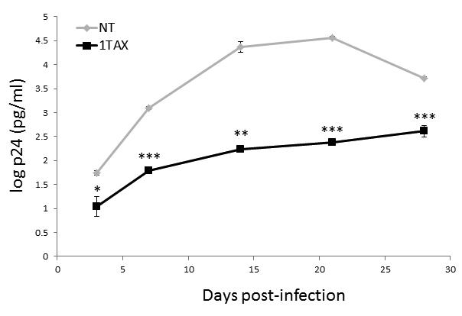
This is great news for the HIV/AIDS research field; the transplantation of a highly homogenous protected HSPC population maintains an HIV-resistant immune system so to fight the opportunistic infections which cause reduced quality of life and mortality. The authors note that their study experimentally mimics results observed in the “Berlin patient”, and in doing so, opens the door for much awaited and much needed clinical trials for a very encouraging therapy. If this proves to function well in human patients, the combination of this therapy with patient-specific induced pluripotent stem cell (iPSC) technology and well understood differentiation techniques could further enhance this therapeutic strategy.
Discussion Points
- Will this strategy function well in human patients?
- Can embryonic stem cells/induced pluripotent stem cell-derived HSPCs be used in this strategy?
- Is this strategy viable in the very long term?
References
- Bauer G and Anderson JS Stem cell transplantation in the context of HIV--how can we cure HIV infection? Expert Rev Clin Immunol 2014;10:107-116.
- Zhen A and Kitchen S Stem-cell-based gene therapy for HIV infection. Viruses 2014;6:1-12.
- Hutter G, Nowak D, Mossner M, et al. Long-term control of HIV by CCR5 Delta32/Delta32 stem-cell transplantation. The New England journal of medicine 2009;360:692-698.
- Hutter G and Thiel E Allogeneic transplantation of CCR5-deficient progenitor cells in a patient with HIV infection: an update after 3 years and the search for patient no. 2. Aids 2011;25:273-274.
- Anderson JS, Javien J, Nolta JA, et al. Preintegration HIV-1 inhibition by a combination lentiviral vector containing a chimeric TRIM5 alpha protein, a CCR5 shRNA, and a TAR decoy. Molecular therapy : the journal of the American Society of Gene Therapy 2009;17:2103-2114.
- Walker JE, Chen RX, McGee J, et al. Generation of an HIV-1-resistant immune system with CD34(+) hematopoietic stem cells transduced with a triple-combination anti-HIV lentiviral vector. Journal of virology 2012;86:5719-5729.
- Barclay SL, Yang Y, Zhang S, et al. Safety and Efficacy of a tCD25 Preselective Combination Anti-HIV Lentiviral Vector in Human Hematopoietic Stem and Progenitor Cells. Stem Cells 2015;33:870-879.

